Leveraging Fitness Tracker Data and ‘Dementia Pets’ to Combat Hypertension in Baby Boomers

Jolene Branch

Bellevue University

Tomah, WI 54660, USA

jobranch@my365.bellevue.edu

Bill Emmons

Bellevue University

Louisa, VA 23093, USA

wemmons@my365.bellevue.edu

Bryan Willis

Bellevue University

Fort Worth, TX 76244, USA

bkwillis@my365.bellevue.edu

# Abstract

# Fitness trackers already have capability to share information with other electronic devices and observing one on a wrist is a common occurrence. Even though traditional ‘pet therapy has been known to be emotionally beneficial for many years’ [8] use of electronic pets in care settings as a method of calming and comforting people with dementia has grown in acceptance within the last decade. Additionally, ‘robotic pets have been shown to have similar positive effects without the negative aspects of traditional pets’ [8] essentially due to Hasbro’s release of their ‘Joy for All’ pets, which respond to environmental cues to prompt actions that generally promote human interaction. Reports from staff and family are favorable, noting a decrease in behavioral incidents requiring medication or removal from the setting. The same concept of the ‘pet’ recognizing pre-determined environmental stimuli (such as a high blood pressure reading) and inviting the human to interact would be incorporated to prevent prolonged hypertensive episodes by using biometric thresholds (such as elevated pulse or blood pressure) to trigger the pet to seek out the human wearing the fitness tracker and invite interaction. The paper will describe at a high level the events that will transpire in our dream project. Our first order of business will be to narrow down the field of available technology to a workable set. We are planning to work with a talented group of computer science students from Bellevue University using a subset of current algorithms on the data gathered and one of our first challenges will be to model and pick the right algorithm. The authors of ‘Implementation of owner distinction function for therapeutic pet robots’ [9] implement a ‘real‐time matching algorithm and a forgetting mechanism’ [9] that we are interested in learning about for possible data exploitation.

# Author Keywords

Hypertension; robotic pet; dementia; biometric data; fitness tracker; Baby Boomer.

# Association for Computing Machinery (ACM) Classification Keywords

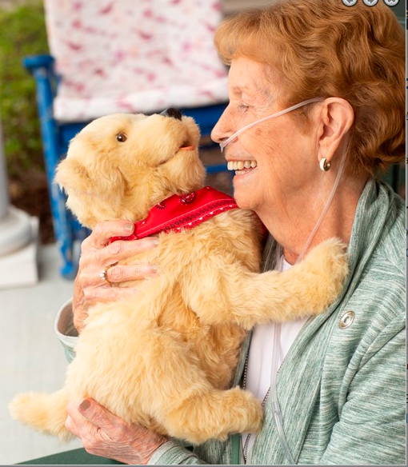

Figure 1: Image of an 80 year old woman wearing oxygen tubing smiling, holding, and petting a robotic dog.

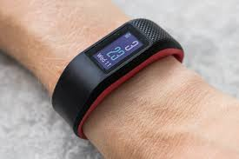

Figure 2: Image of a generic fitness tracker shown worn on a wrist.

J.3 Life and Medical Sciences: Biology and genetics; K.4.2 Social Issues: Assistive technology for persons with disabilities

# Motivation

# In each of our lives we have either experienced, or know someone close to us who has experienced, an untimely heart attack. We believed applying data science alongside the right technology would reduce and in time prevent untimely heart attacks by providing the most susceptible individuals tools to provide first and foremost comfort and medical assistance in a timely manner.

# Introduction

It has been widely reported that animal-assisted therapy can help individuals cope with stress, reduce depression, prevent loneliness and improve socialization. However, for a home health, hospice patient or someone trying to manage hypertension, a pet can also be burdensome. The added daily responsibility of all that comes along with caring for a pet could cause additional stress to the patient. While the benefits and value of pet-assisted therapies patients can’t be denied, the liability and risks associated with incorporating live pets into a patient’s life or health care setting may not always be the best option. A viable option that may alleviate these liabilities and risks is the combination of an electronic pet (ex. robot dog) with Bluetooth-fitness tracker technology (worn by patient). The ability to integrate technology and physiology enables biometric data to be passed from the patient’s fitness tracker to the electronic pet. The electronic pet responds appropriately according to the data that is received in order to reduce or report the symptom.

**Medical community**

We believe our best chances of success will come from teaming up with leading researchers in the field and are hopeful to be able to complete a cohort with the Mayo Clinic. In addition, we are planning to work with a number of medical professionals from the Veterans Hospitals on our project. The insight and knowledge these professional will be able to provide the data scientist on the team will be crucial to the project.

**Data Science & Technology**

Our first order of business will be to narrow down the field of available technology to a workable set. We will focus our initial energy on the devised which ultimately would provide the greatest amount of viable data points; Hasbro ‘Joy for All’ pets, for its reasonable price and real life look and feel, Fitbit for its ease of use, and either amazon echo or google dot for communication and we hope to collaborated with the authors of ‘Review Smart Homes for Elderly Healthcare’ [1] for valuable additional insight in home sensors.

We are planning to work with a talented group of computer science students from Bellevue University for assistance on data mining throughout the project. We have narrowed our initial list of possible algorithm to Support Vector Machine, Neutral Network, Logistic Regression,

Discrimination Analysis, Random Forest, Linear Regression, Naïve Bayes, Nearest Neighbor, Decision Tree and Hidden Markov. We are aware many of these may not ultimately provide valuable output, however we do not want to limit ourselves at the outset of the project.

**Conclusion**

While at this point, this is only a ‘dream project’ we are hopeful the key components identified will allow for a successful project. We know there is the potential for many ups and downs, all of the desired players may not be able to participate and the task may prove to be beyond our skill, however we wished to DREAM big because of the end value with could be added to humanity.

**Acknowledgements**

We thank all the human volunteers, clinical staff, anthropologists, and data scientists, who will test and/or provide helpful comments on future versions of this product,

# References

1. Majumder, Sumit Majumder, Aghqyi, Emad Aghayi, Noferesti, Memarzadeh-Tehran, Hamidreza, Mondal, Tapas, Pang, Zhibo and Deen, Jamal M. (2017/10/31). Review Smart Homes for Elderly Healthcare—Recent Advances and Research Challenges. Retrieved from <https://www.mdpi.com/1424-8220/17/11/2496/htm>
2. Bradshaw, John (2017). The animals among us: how pets make us human. New York, NY: Basic Books
3. Chau, Diane MD, FACP and Osborne, Thomas F. MD. (2018) Social Robots and Other Relational Agents to Improve Patient Care in *Using Technology to Improve Care of Older Adults* (pp. 227 – 245) New York, NY: Springer Publishing Company, LLC
4. Thompson, Steve J. (2018) Androids, Cyborgs, and Robots in Contemporary Culture and Society. Hershey, PA: IGI Global
5. Marsilio, Jilian N., McKittrick, Samantha V., Umbell, Lisa R., Garner, Melissa A., Maiewski, Sharon, and Wenos, Jeanne. (2018, 12, 12) Effects of a robotic cat on agitation and quality of life in individuals with dementia in a long- term care facility.
6. Oetting, Amy Nicole (2016). Preventive computing technology for successful aging.
7. Virue´s-Ortega, MS, Javier and Buela-Casal, PhD, Gualberto (2016) Psychophysiological Effects of Human-Animal Interaction Theoretical Issues and Long-Term Interaction Effects
8. Petersen, S., Houston, S., Qin, H., Tague, C., & Studley, J. (). The Utilization of Robotic Pets in Dementia Care. Journal of Alzheimer's disease : JAD, 55(2), 569–574. doi:10.3233/JAD-160703
9. Hidetaka Nambo, Haruhiko Kimura, Sadaki Hirose, "Implementation of owner distinction function for therapeutic pet robots", First published: 19 June 2009, https://doi.org/10.1002/eej.20882